Stored Procedure -

1)
CREATE PROCEDURE GetCustomerInfo
@customer_id VARCHAR(5),
@first_name VARCHAR(50) OUTPUT,
@last_name VARCHAR(50) OUTPUT,
@address VARCHAR(100) OUTPUT,
@city VARCHAR(50) OUTPUT
AS
BEGIN
SELECT
@first_name = First_Name,
@last_name = Last_Name,
@address = Address,
@city = City
FROM Customer
WHERE Customer_ID = @customer_id;
END;

-- Declare variables for input and output parameters
DECLARE @CustomerID VARCHAR(5) = 'C001';
DECLARE @FirstName VARCHAR(50);
DECLARE @LastName VARCHAR(50);
DECLARE @CustomerAddress VARCHAR(100); -- Renamed the variable to avoid conflicts
DECLARE @CustomerCity VARCHAR(50);

-- Execute the stored procedure
EXEC GetCustomerInfo
@customer_id = @CustomerID,
@first_name = @FirstName OUTPUT,
@last_name = @LastName OUTPUT,
@address = @CustomerAddress OUTPUT,
@city = @CustomerCity OUTPUT;

-- Display the result
SELECT
'Customer ID: ' + @CustomerID AS 'Input Parameter',
'First Name: ' + ISNULL(@FirstName, 'N/A') AS 'First Name',
'Last Name: ' + ISNULL(@LastName, 'N/A') AS 'Last Name',
'Address: ' + ISNULL(@CustomerAddress, 'N/A') AS 'Address',
'City: ' + ISNULL(@CustomerCity, 'N/A') AS 'City';

Output -
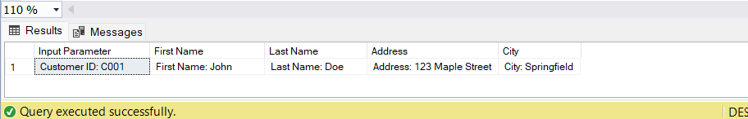

2)

CREATE PROCEDURE GetBillingDetails
@invoice_number VARCHAR(50),
@customer_id VARCHAR(5) OUTPUT,
@plan_name VARCHAR(100) OUTPUT,
@payment_status VARCHAR(20) OUTPUT
AS
BEGIN
SELECT
@customer_id = c.Customer_ID,
@plan_name = p.Plan_Name,
@payment_status = b.Payment_Status
FROM Billing b
INNER JOIN Customer c ON b.Customer_ID = c.Customer_ID
INNER JOIN Plans p ON b.Plan_ID = p.Plan_ID
WHERE b.Invoice_Number = @invoice_number;
END;

-- Declare variables for input and output parameters
DECLARE @InvoiceNumber VARCHAR(50) = 'INV0001';
DECLARE @CustomerID VARCHAR(5);
DECLARE @PlanName VARCHAR(100);
DECLARE @PaymentStatus VARCHAR(20);

-- Execute the stored procedure
EXEC GetBillingDetails
@invoice_number = @InvoiceNumber,
@customer_id = @CustomerID OUTPUT,
@plan_name = @PlanName OUTPUT,
@payment_status = @PaymentStatus OUTPUT;

-- Display the result
SELECT
'Invoice Number: ' + @InvoiceNumber AS 'Input Parameter',
'Customer ID: ' + ISNULL(@CustomerID, 'N/A') AS 'Output Parameter',
'Plan Name: ' + ISNULL(@PlanName, 'N/A') AS 'Output Parameter',
'Payment Status: ' + ISNULL(@PaymentStatus, 'N/A') AS 'Output Parameter';

Output →
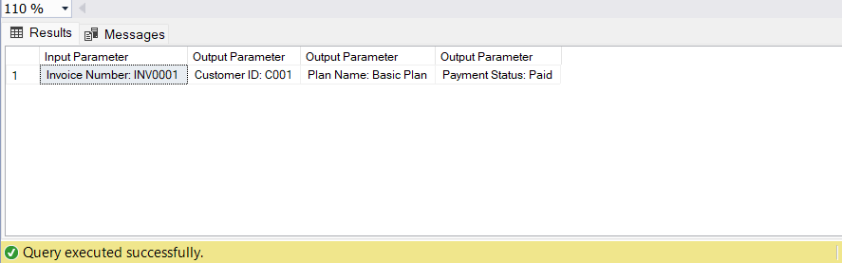

3)

CREATE PROCEDURE UpdateEmployeeSalary
@employee_id VARCHAR(5),
@new_salary DECIMAL(10, 2),
@message VARCHAR(255) OUTPUT
AS
BEGIN
UPDATE Employee
SET Salary = @new_salary
WHERE Employee_ID = @employee_id;

IF @@ROWCOUNT > 0
SET @message = 'Salary updated successfully.';
ELSE
SET @message = 'Employee not found.';
END;

DECLARE @outputMessage NVARCHAR(255);
EXEC UpdateEmployeeSalary 'E001', 80000.00, @message = @outputMessage OUTPUT;
PRINT @outputMessage;

Output →
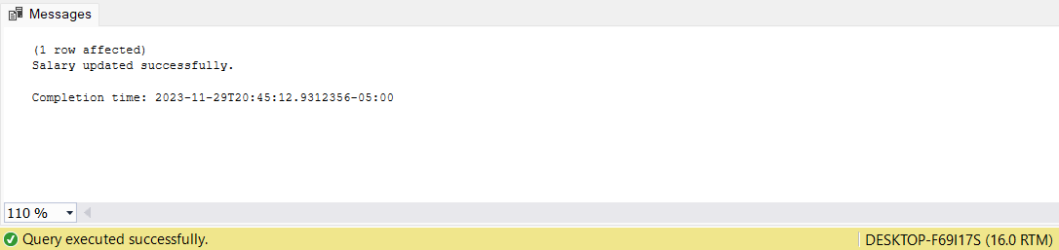

4)
CREATE PROCEDURE CalculateEmployeeBonus
@EmployeeID VARCHAR(5),
@BonusPercentage DECIMAL(5, 2),
@BonusAmount DECIMAL(10, 2) OUTPUT
AS
BEGIN
DECLARE @EmployeeSalary DECIMAL(10, 2);

-- Get the employee's salary
SELECT @EmployeeSalary = Salary
FROM Employee
WHERE Employee_ID = @EmployeeID;

-- Calculate the bonus
SET @BonusAmount = @EmployeeSalary * (@BonusPercentage / 100);
END;

-- Declare variables for input and output parameters
DECLARE @employeeID VARCHAR(5) = 'E001';
DECLARE @bonusPercentage DECIMAL(5, 2) = 10;
DECLARE @bonusAmount DECIMAL(10, 2);

-- Execute the stored procedure
EXEC CalculateEmployeeBonus @employeeID, @bonusPercentage, @bonusAmount OUTPUT;

-- Display the calculated bonus
SELECT 'Bonus Amount: ' + CAST(@bonusAmount AS VARCHAR(20)) AS Result;

Output →
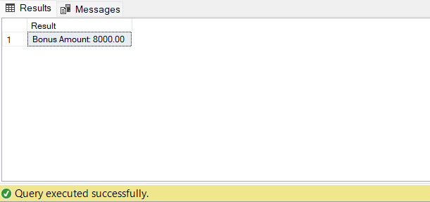

VIEW (often used for reporting purposes) →

1.

CREATE VIEW CustomerBillingView AS
SELECT
c.Customer_ID,
c.First_Name,
c.Last_Name,
b.Invoice_Number,
b.Payment_Status
FROM Customer c
INNER JOIN Billing b ON c.Customer_ID = b.Customer_ID;

SELECT * FROM CustomerBillingView;

Output →

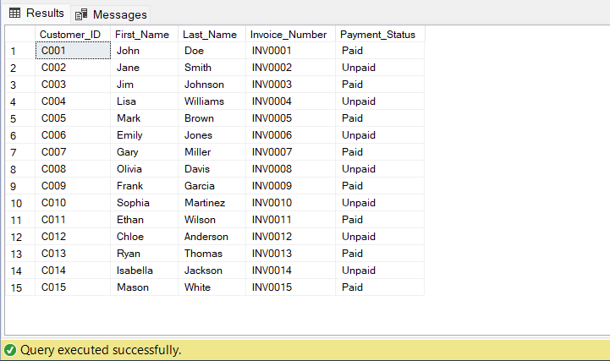

2)

CREATE VIEW EmployeeDepartmentView AS
SELECT
e.Employee_ID,
e.First_Name,
e.Last_Name,
d.Department_Name
FROM Employee e
INNER JOIN Department d ON e.Department_ID = d.Department_ID;

SELECT * FROM EmployeeDepartmentView;

Output →
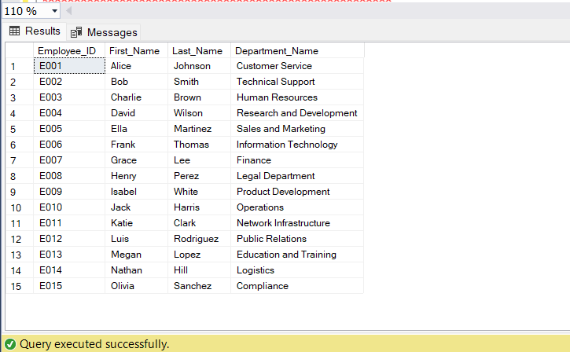

3)
CREATE VIEW ServiceSubscriptionDetailsView AS
SELECT
ss.Subscription_ID,
ss.Start_Date,
ss.End_Date,
p.Plan_Name,
s.Service_Type
FROM ServiceSubscription ss
INNER JOIN Plans p ON ss.Plan_ID = p.Plan_ID
INNER JOIN Service s ON ss.Service_ID = s.Service_ID;

SELECT * FROM ServiceSubscriptionDetailsView;

Output →

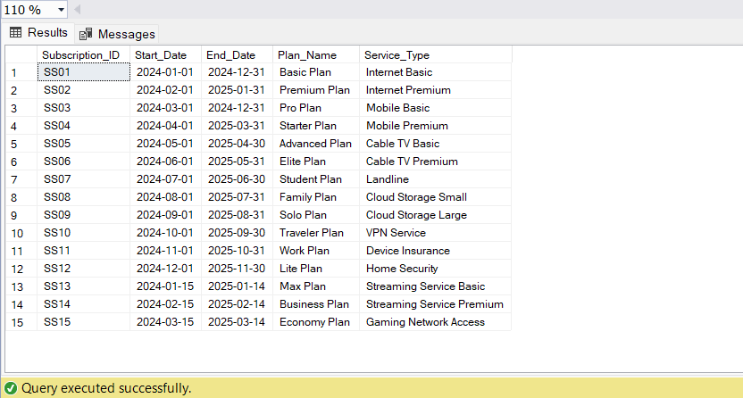

4)
-- View 4th Code
CREATE VIEW EmployeeLocationView AS
SELECT
E.Employee_ID,
E.First_Name,
E.Last_Name,
E.Salary,
L.Location_Name,
L.Population
FROM
Employee E
INNER JOIN
Location L ON E.Location_ID = L.Location_ID;

SELECT * FROM EmployeeLocationView;

Output →

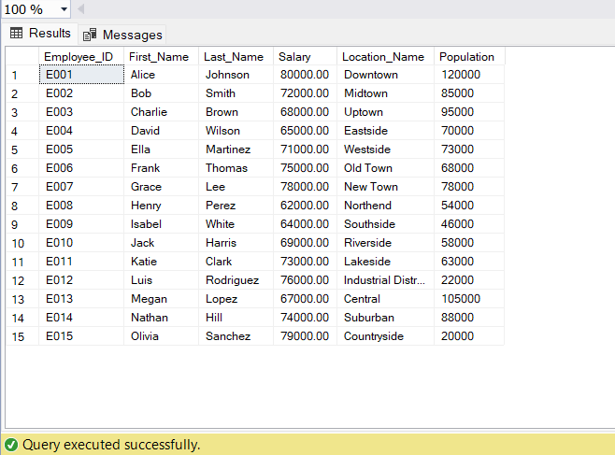

- Trigger →

CREATE TRIGGER UpdateServiceSubscription
ON ServiceSubscription
AFTER UPDATE
AS
BEGIN
-- Trigger logic to perform actions after updating ServiceSubscription table
-- Example: Logging the update in an audit table
INSERT INTO ServiceSubscriptionAudit (Subscription_ID, Updated_At)
SELECT Subscription_ID, GETDATE()
FROM INSERTED;
END;

- Check Constraints →

ALTER TABLE Customer
ADD CONSTRAINT CheckAgeConstraint CHECK (DATEDIFF(YEAR, Date_of_Birth, GETDATE()) >= 18);

ALTER TABLE ServiceSubscription
ADD CONSTRAINT CheckEndDateConstraint CHECK (End_Date > Start_Date);

ALTER TABLE Location
ADD CONSTRAINT CheckPopulationConstraint CHECK (Population >= 0);

- User- Defined function (UDF) →

CREATE FUNCTION dbo.CalculateDiscount
(
@InvoiceAmount DECIMAL(10, 2)
)
RETURNS DECIMAL(5, 2)
AS
BEGIN
DECLARE @Discount DECIMAL(5, 2);

-- Example discount calculation logic: 10% discount for amounts greater than 100
IF @InvoiceAmount > 100
SET @Discount = 0.10 * @Invoice_Amount;
ELSE
SET @Discount = 0;

RETURN @Discount;
END;

ALTER TABLE Billing
ADD Invoice_Amount FLOAT;

UPDATE Billing
SET Invoice_Amount = RAND() * 1000;

ALTER TABLE Billing
ADD Discount AS dbo.CalculateDiscount(Invoice_Amount);

SELECT * , Discount
FROM Billing;

Output →

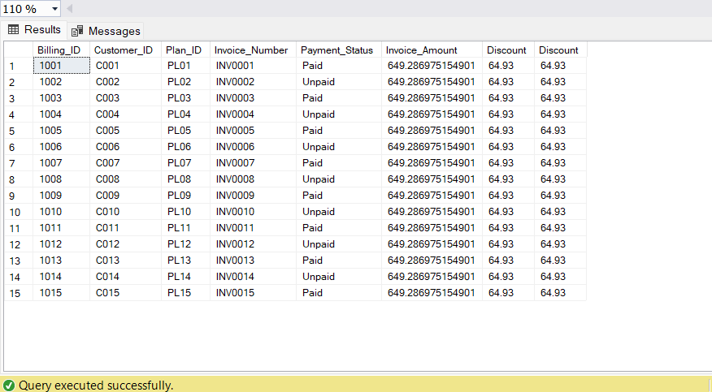

- Column Data Encryption →

CREATE SYMMETRIC KEY Customer_IDKey
WITH ALGORITHM = AES_256
ENCRYPTION BY PASSWORD = 'DMDD123';

ALTER TABLE Customer
ADD EncryptedCustomer_ID VARBINARY(MAX);

OPEN SYMMETRIC KEY Customer_IDKey
DECRYPTION BY PASSWORD = 'DMDD123';

UPDATE Customer
SET EncryptedCustomer_ID = ENCRYPTBYKEY(KEY_GUID('Customer_IDKey'), CONVERT(VARBINARY(MAX), Customer_ID));

CLOSE SYMMETRIC KEY Customer_IDKey;

SELECT * FROM Customer;

Output →

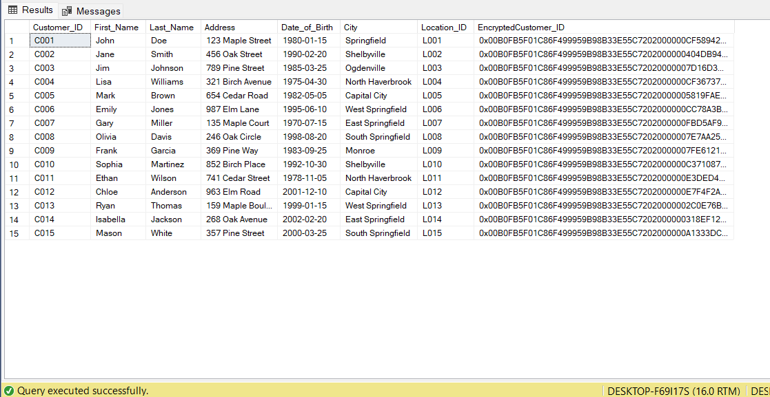

- Non-Clustered Indexes →

CREATE NONCLUSTERED INDEX IX_Customer_LastName
ON Customer(Last_Name);

CREATE NONCLUSTERED INDEX IX_Employee_DepartmentID
ON Employee(Department_ID);

CREATE NONCLUSTERED INDEX IX_Billing_PlanID
ON Billing(Plan_ID);

